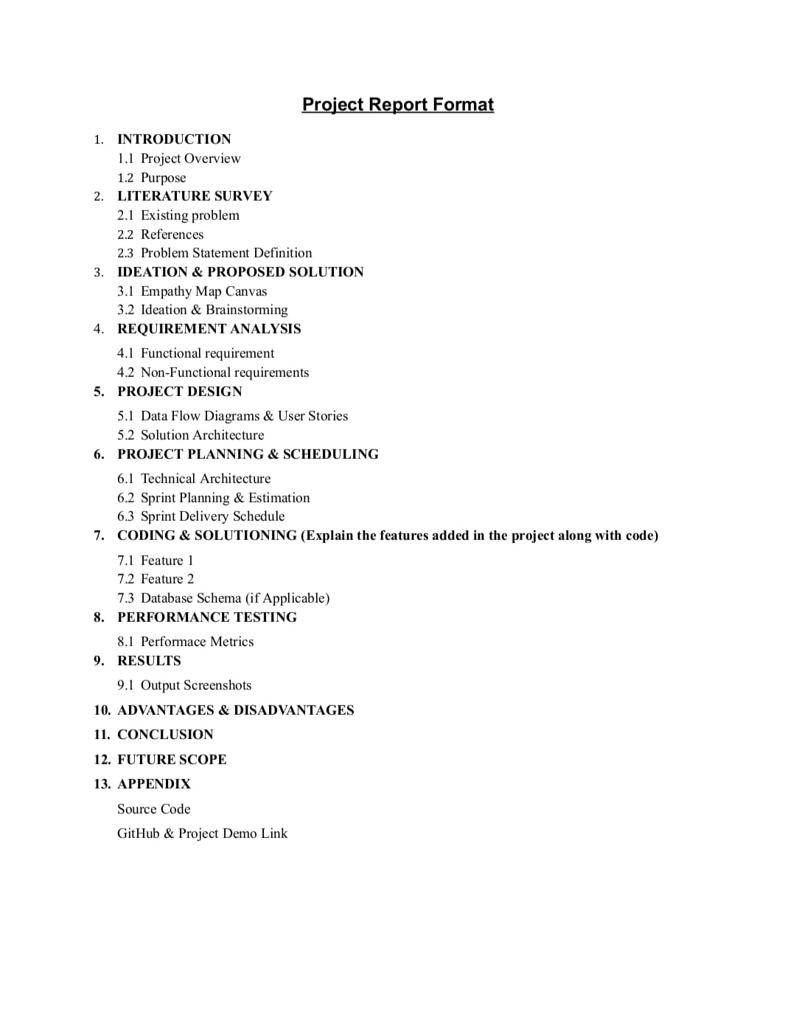

**INTRODUCTION**

**PROJECT OVERVIEW**

The primary objective of a vaccine tracking project is to facilitate the distribution, administration, and monitoring of vaccines to ensure public health and safety. This includes tracking various vaccines, such as those for infectious diseases like COVID-19, influenza, measles, polio, and others.

A vaccine tracking project using blockchain leverages distributed ledger technology to enhance the efficiency, security, and transparency of vaccine distribution and administration. This innovative system ensures accurate recording of vaccination data, secure data sharing, and real-time tracking. It facilitates appointment scheduling, inventory management, and adverse event reporting, providing a user-friendly interface for both patients and healthcare providers. The blockchain's immutability and transparency instill trust in the vaccination process, while data analytics enable informed decision-making. By seamlessly integrating various stakeholders and processes, this project optimizes vaccination programs, reduces errors, and safeguards public health during critical times.

A vaccine tracking project plays a crucial role in public health, particularly during pandemics and large-scale vaccination efforts, by ensuring the efficient and safe distribution of vaccines to the population. It requires collaboration between healthcare providers, government agencies, and technology experts to implement and maintain successfully.

**PURPOSE**

Vaccine tracking using blockchain technology serves a multi-faceted purpose, revolutionizing the management of vaccines from distribution to administration and monitoring. First and foremost, it ensures the security and integrity of vaccination data. The blockchain's decentralized and tamper-resistant ledger makes it nearly impossible for unauthorized alterations to occur, fostering accuracy and reliability in vaccine records. This integrity is paramount for maintaining public trust and meeting regulatory compliance standards.Blockchain's real-time tracking capability in vaccine supply chains is another crucial purpose. By recording each transaction on the blockchain, it creates an immutable record of vaccine movement. This transparency is vital for guaranteeing that vaccines are stored and transported within the required temperature range, safeguarding their effectiveness and preventing spoilage.Efficient inventory management is also a key benefit. By allowing automated, real-time updates to vaccine inventories, blockchain streamlines their management. This ensures that healthcare providers have the vaccines they require when needed, thus reducing shortages and wastage.User-friendly interfaces and mobile applications are often included in blockchain-based vaccine tracking projects, enhancing convenience for patients. This approach simplifies appointment scheduling and provides secure access to vaccination records, thus encouraging patient participation in vaccination programs.Furthermore, blockchain facilitates the reporting of adverse events related to vaccines. The secure and transparent nature of the blockchain simplifies the process and enables the swift identification of safety concerns, facilitating timely responses.Data analytics integrated with blockchain systems offer valuable insights for public health officials and policymakers. These insights empower informed decision-making, helping allocate resources efficiently, plan vaccination campaigns, and identify areas with low vaccine coverage.Blockchain's interoperability capabilities ensure that patients' vaccine records are accessible and up-to-date across various healthcare providers. It also empowers individuals to own and control their vaccine-related data, granting or revoking access as needed, thus ensuring data privacy and autonomy.Finally, the security and transparency of blockchain foster trust among all stakeholders in the vaccination process, including patients, healthcare providers, regulators, and the public. This increased trust is essential for achieving high vaccination coverage and the overall success of vaccination programs.

**2. LITERATURE SURVEY**

**2.1 Existing problem :**

One existing problem in vaccine tracking is the lack of a standardized and centralized system for recording and monitoring vaccine distribution and administration. This can lead to challenges in ensuring vaccines reach their intended recipients and managing inventory effectively. Additionally, issues related to data accuracy, privacy, and security can complicate vaccine tracking efforts.

**2.2 References :**

* Fighting Counterfeit Pharmaceuticals: New Defenses for an Underestimated-and Growing-Menace.
* Sgueglia, K. 15 People Face Charges in Connection to a Conspiracy with Fake COVID-19 Vaccine Cards, DA Says.
* Shuster, S. ‘Tip Of the Iceberg’: Interpol Says Fake COVID-19 Vaccines Were Smuggled Across Continents.
* Nakamoto, S. Bitcoin: A peer-to-peer electronic cash system. Decentralized Bus. Rev. 2008, 21260. [Google Scholar]
* Porat, A.; Pratap, A.; Shah, P.; Adkar, V. Blockchain Consensus: An Analysis of Proof-of-Work and Its Applications; Stanford University: Stanford, CA, USA, 2017;

**2.3 Problem Statement Defination :**

The existing vaccine distribution systems face several critical issues that hinder their effectiveness. To address these challenges, the development of a blockchain-based vaccine tracking system is imperative. This system aims to tackle problems such as supply chain transparency, counterfeiting, data integrity, inventory management, and public trust.

The current vaccine supply chain lacks end-to-end visibility, making it challenging to monitor the origins, storage, and transportation of vaccines. Counterfeit vaccines are a serious concern, risking public health. Data integrity issues may lead to inaccuracies in vaccine distribution records, causing inefficiencies and security risks. Poor inventory management can result in vaccine shortages or wastage. Restoring public trust in vaccine distribution is crucial, and blockchain technology can play a pivotal role in achieving this by providing tamper-proof and transparent records.

**3. IDEATION & PROPOSED SOLUTION :**

**3.1 Empathy Map Canvas :**

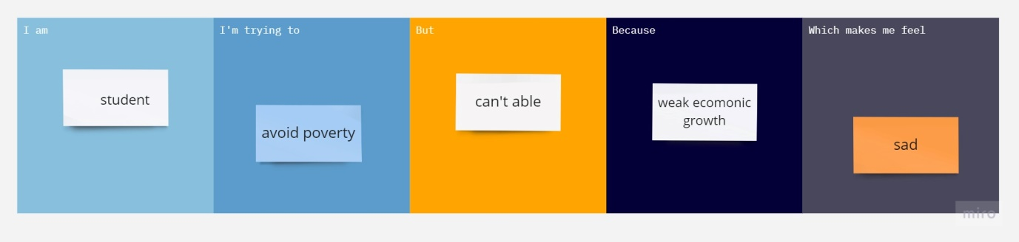

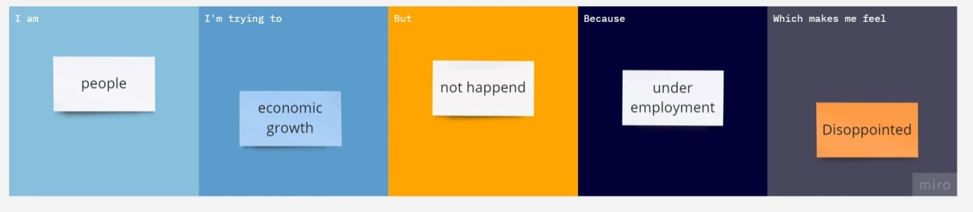

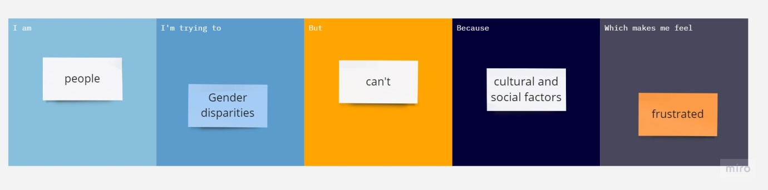

|  |  |  |  |  |
| --- | --- | --- | --- | --- |
| **I am (Customer)** | **I am trying to** | **But** | **Because** | **Which makes me feel** |
| Healthcare Provider | Streamline vaccine distribution | often fragmented with limited visibility into vaccine availability | Lack of integration and coordination | Frustrated and concerned about the potential negative impact on public health |
| Vaccine Recipient | Provide an user centric platform for individuals to schedule vaccine appointments | Existing system often lacks user friendliness | Frustration and confusion among vaccine recipients | Overwhelmed and anxious about the vaccination process |
| Healthcare administrator | Streamline vaccine inventory management | Current inventory process are often manual and prone to errors | Inefficiency leads to vaccine shortages and overstocking | Stressed and overwhelmed by the unpredictable vaccine supply |

**3.1 Empathy Map Canvas :**

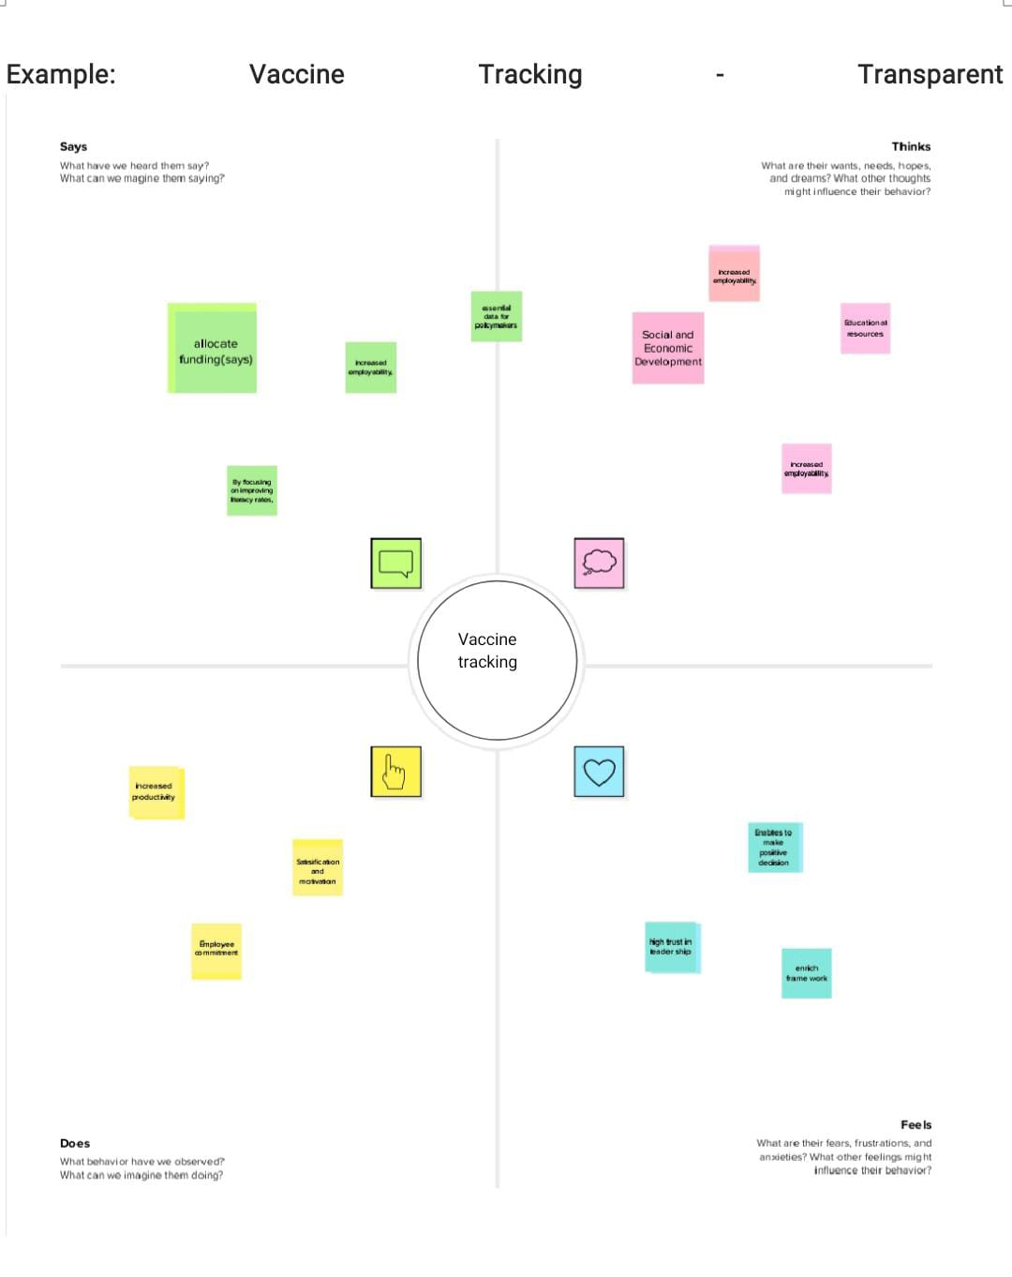

**3.2 Ideation & Brainstorming :**

STEP:1 Team gathering, Collaboration and Select the problem statement

**PROBLEM :**

Inefficient vaccine tracking and administration processes hinder the timely and safe distribution of vaccines, causing delays, errors, and vaccine wastage. The absence of a streamlined system for scheduling appointments, managing vaccine inventory, and monitoring adverse events complicates the vaccination process. Healthcare providers and recipients face challenges accessing vaccination records and scheduling appointments, while public health officials lack real-time data to make informed decisions. These inefficiencies undermine the overall vaccination effort, jeopardizing public health goals, and eroding confidence in vaccination programs. A comprehensive vaccine tracking project is needed to address these issues and ensure the efficient and accountable management of vaccines.

STEP:2 Brainstorm idea, listing and grouping

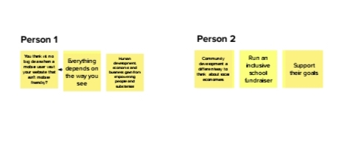

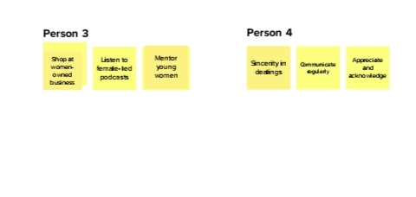

**GROUP IDEAS**

Creating a comprehensive vaccine tracking project requires a diverse team of professionals and experts. The development team is responsible for building the tracking software, while data analytics experts focus on data collection and analysis. Medical and logistics experts ensure alignment with medical standards and efficient vaccine distribution. Public health officials provide insights into vaccination strategy, while patient advocates prioritize user-friendliness. Legal experts address privacy and compliance, while ethical hackers enhance cybersecurity. Community outreach and support teams engage the public, and project managers oversee coordination. Collaboration with vaccine manufacturers, international health organizations, and community leaders ensures a well-rounded approach.

STEP:3 Idea Prioritization

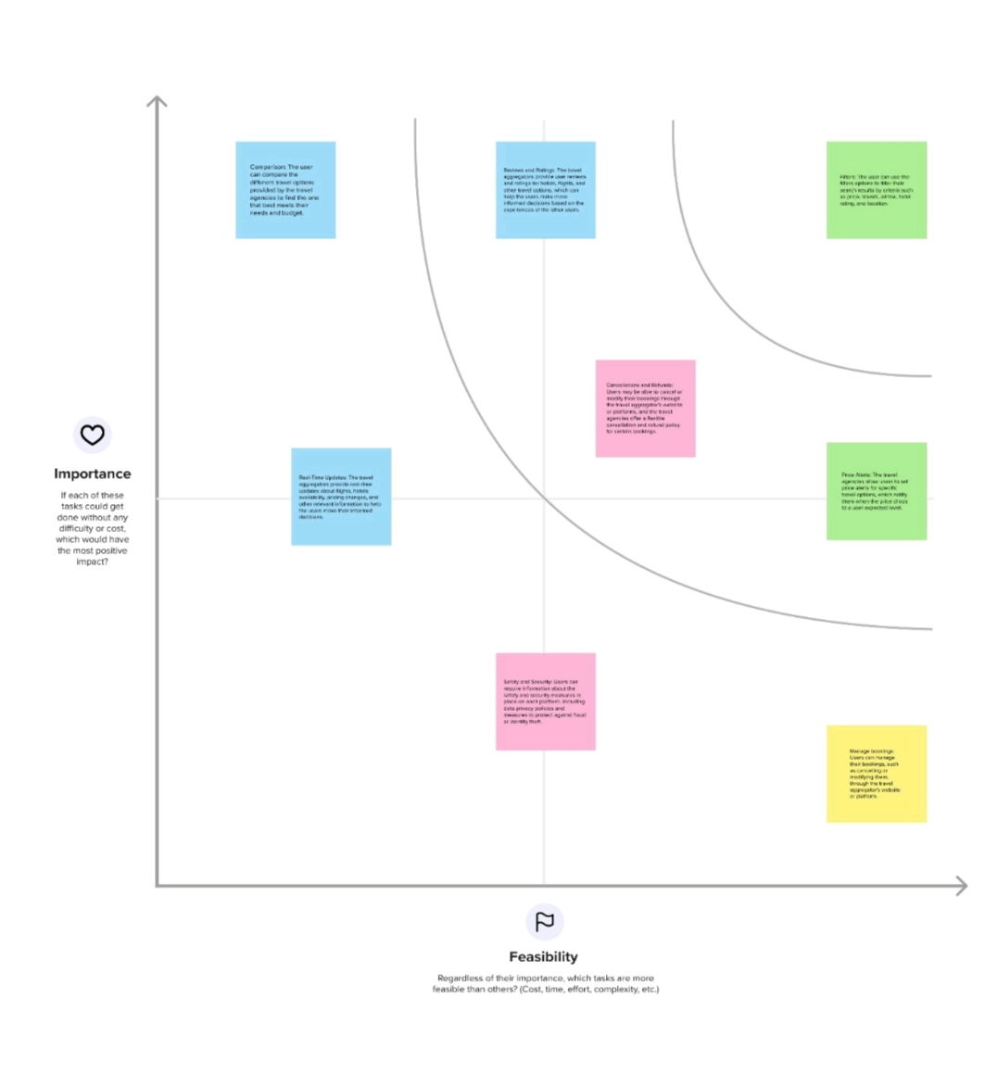

**4. REQUIREMENT ANALYSIS :**

**4.1 Functional requirement :**

|  |  |  |
| --- | --- | --- |
| **FR NO:** | **Functional Requirement(Epic)** | **Sub Requirement(story/sub-task)** |
| FR-1 | User Registration | Registration through from website or gmail |
| FR-2 | User confimation | Confirmation via mail, phone call etc. |
| FR-3 | User Dashboard | Evalute services and features and views user history and ratings. |
| FR-4 | User profile and preferences | Create and manage their profile. |
| FR-5 | Output generation | Report generation,  Content generation  Itinerary generation  Visual generation |

**4.2 Non-Functional requirements :**

|  |  |  |
| --- | --- | --- |
| **FR NO:** | **Non-functional requirements** | **Description** |
| NFR-1 | Usability | User-friendly interface to facilitate the user with easy orocessing.  Model provides data gathering.  Model provides analyze and compare.  Model provides evalution.  Model provides evalution criteria. |
| NFR-2 | Security | Authentication-user can have his/her own private dashboard to have secured access. |
| NFR-3 | Reliability | The model can run numerous samples simultaneously and handle massive amounts of data. |
| NFR-4 | Performance | As the model is a combination of python programming ,the accuracy is high. |
| NFR-5 | Availability | The website is portable and mobile-responsive as well.To run on any device,it simply needs the most minimum requirements. |
| NFR-6 | Scalability | It can be extended futher to provide API which can be used by third party organization such as logistics companies ,etc. |
| NFR-7 | Compliance | It makes sure that all legal criteria are met, and this includes travel industry rules as well as payment card industry standards. |

**5. PROJECT DESIGN :**

**5.1 Data flow diagrams & user stories :**

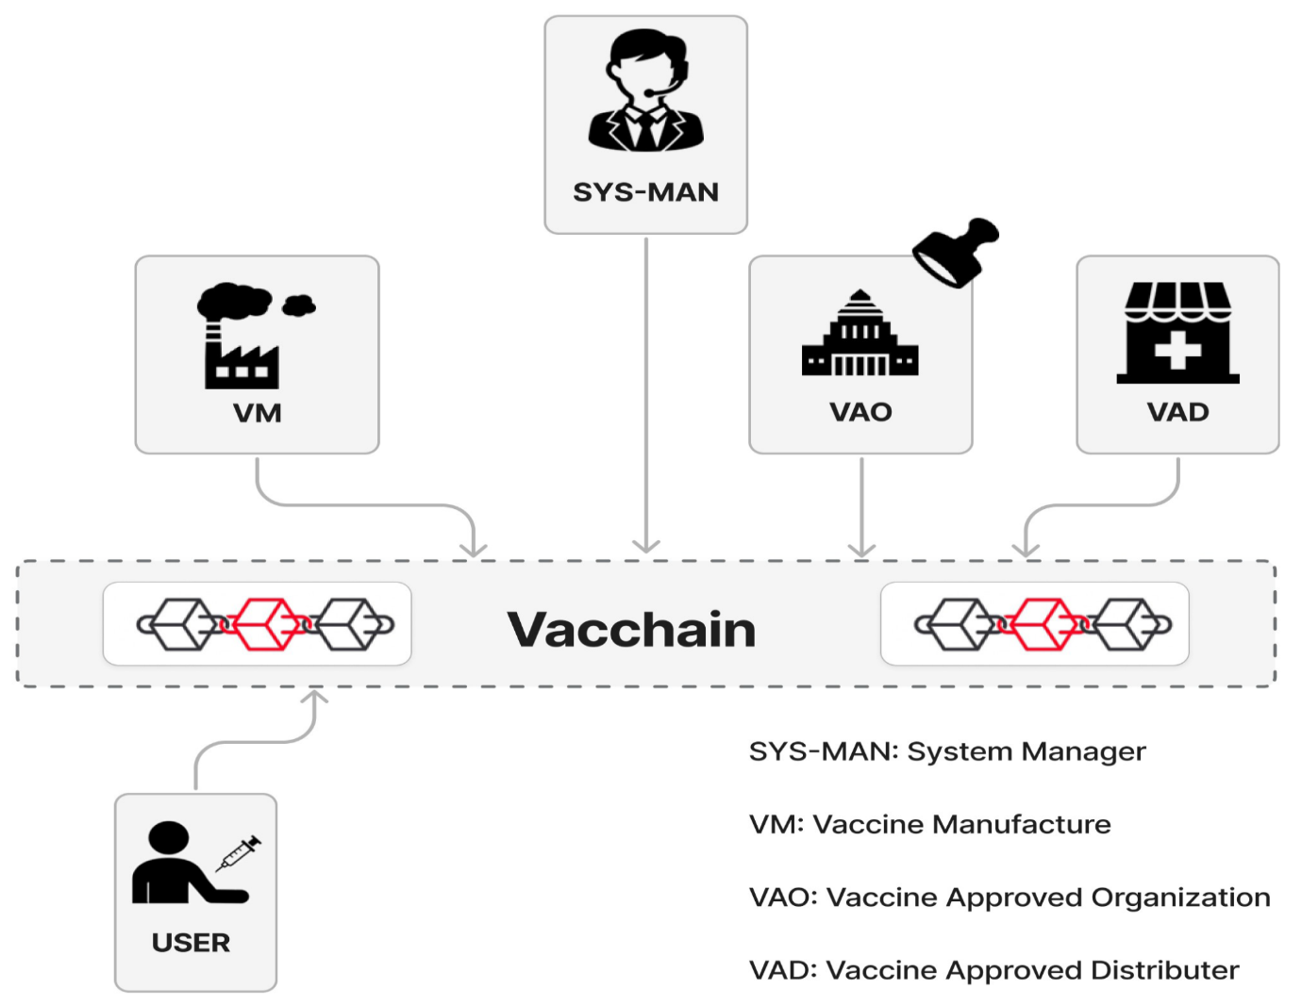

FIG 4.1 DATA FLOW DIAGRAM OF VACCINE TRACKING USING BLOCKCHAIN

**5.2 Solution Architecture :**

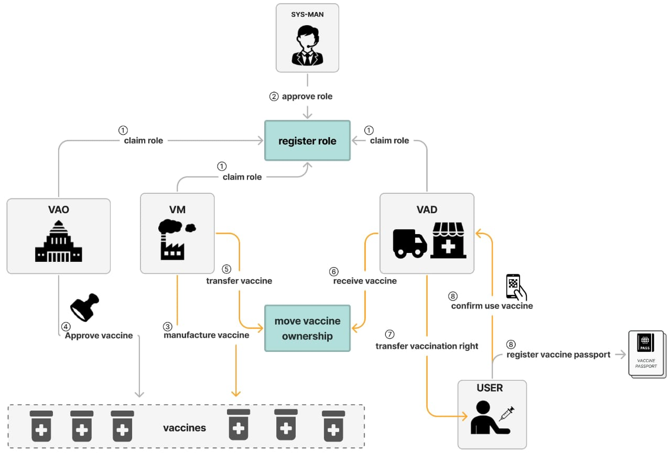

FIG 4.2 SOLUTION ARCHITECTURE FOR VACCINE TRACKING USING BLOCKCHAIN

**6. PROJECT PLANNING & SCHEDULING :**

**6.1 Technical Architecture :**

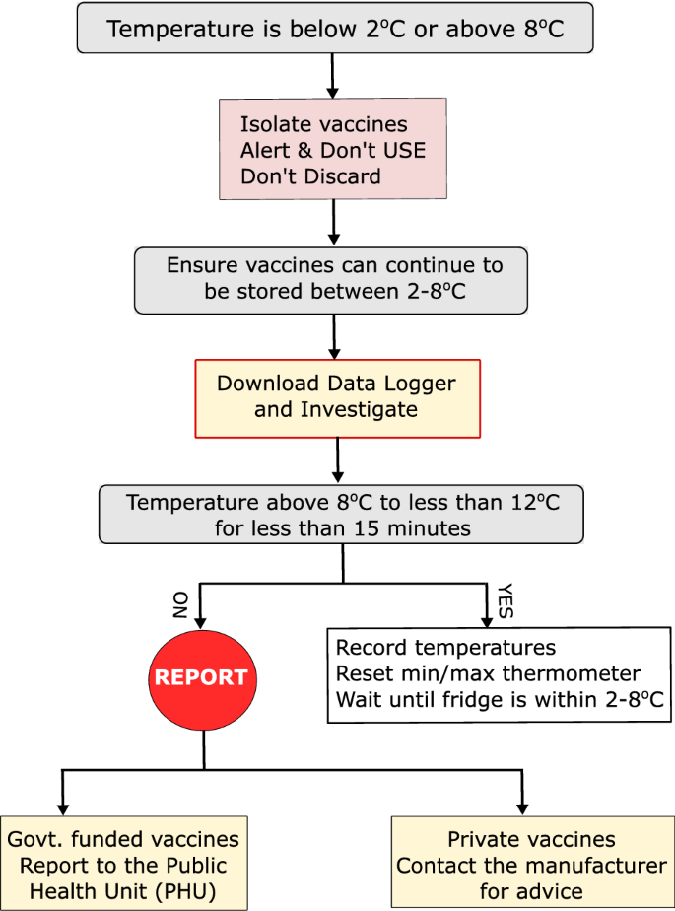

**6.2 Sprint Planning & Estimation :**

Sprint planning and estimation for a blockchain-based vaccine tracking project is a structured approach to manage the development process effectively. This process involves several key steps:

First, it starts with defining user stories and project requirements, outlining the functionalities needed for vaccine tracking, including recording vaccinations, ensuring authenticity, and managing access for authorized users.

Next, prioritization is crucial. User stories are ranked by importance and impact, ensuring that critical elements like data security and transparency take precedence.

Choosing an appropriate sprint duration, typically 2 to 4 weeks, is essential to manage the work efficiently, considering the project's complexity.

Tasks are then broken down into smaller, manageable units, allowing for more accurate estimation of effort. Techniques like story points or hours are used to estimate the time required for each task, and the team reaches a consensus on these estimates.

Capacity planning helps assess the team's capabilities, considering team size and individual member availability during the sprint.

Setting sprint goals that align with the project's overall objectives, such as completing the Minimum Viable Product (MVP) for vaccine tracking, is critical to keep the team focused.

Creating a realistic sprint backlog by selecting a set of user stories and tasks for the sprint allows for a clear plan of action.

Daily stand-up meetings ensure regular progress tracking, problem-solving, and adjustments to the plan.

At the end of the sprint, a review is held to showcase completed work, and a retrospective is conducted to identify areas for improvement in future sprints.

Continuous refinement of the backlog and planning based on changing requirements and feedback is a key feature of this approach.

In summary, sprint planning and estimation provide a structured framework for efficiently developing a blockchain-based vaccine tracking system, ensuring organized progress and adaptation to evolving project needs.

**6.3 Sprint Delivery schedule :**

Creating a sprint delivery schedule for a blockchain-based vaccine tracking project involves structuring the development process into a series of sprints, each with specific goals and tasks. The schedule outlined here covers seven sprints:

1. **Sprint** **1**: focuses on setting up the project infrastructure, establishing the blockchain network, and creating basic user interfaces for data input.
2. **Sprint 2**: centers on implementing core features related to vaccine data recording, such as smart contract development and data security.
3. **Sprint 3**: aims to enhance data verification and access control, incorporating user roles and conducting security testing.
4. **Sprint 4**: extends functionality and user access by adding support for mobile applications and improving user interfaces.
5. **Sprint 5**: focuses on finalizing the system, conducting testing, and preparing for deployment, ensuring a thoroughly tested and documented vaccine tracking system.
6. **Sprint 6**: is dedicated to deployment and initial user training, including system monitoring and issue resolution.
7. **Sprint 7**: follow, focusing on continuous improvement, feature updates, scalability, and maintaining the system as it is in use.

The schedule allows for flexibility and adaptation to changing project needs. Effective communication with stakeholders throughout the process is vital to ensure alignment with their requirements and expectations. This structured approach helps manage the development of a blockchain-based vaccine tracking system efficiently and ensures that it evolves to meet evolving demands and challenges.

**7.CODING & SOLUTION :**

**7.1 Feature 1:**

The proposed solution outlines the development of a vaccine tracking system using blockchain technology, with a focus on "Immutable Record Storage" as a key feature. In this system, smart contracts would play a central role. These contracts would be created on a blockchain platform like Ethereum and define the structure of vaccine data while ensuring its immutability.

Authorized parties, such as vaccine manufacturers and healthcare providers, would be responsible for inputting vaccine-related information into the blockchain. Once this data is recorded, it becomes unchangeable due to the inherent characteristics of blockchain technology, preventing any fraudulent alterations to vaccine records.

Access control measures would be in place to restrict who can add or modify vaccine data, enhancing security. Users would have the ability to verify the authenticity of vaccines by querying the blockchain, allowing them to confirm if a vaccine batch matches the records stored in the blockchain.

* 1. **Feature 2:**

To make the system user-friendly, a web or mobile application interface would be developed, enabling users to input batch numbers or scan QR codes for quick verification. Additionally, notification features would be integrated, ensuring that stakeholders in the vaccine supply chain receive alerts and updates regarding vaccine movements.

By incorporating these elements, the proposed vaccine tracking system would provide a secure, transparent, and trustworthy means of monitoring vaccine data throughout the supply chain, thereby contributing to the safety and integrity of vaccination efforts.

**8.PERFORMANCE TESTING :**

**8.1 Performance Metrics :**

The use of blockchain technology for vaccine tracking offers several key performance metrics to gauge its effectiveness in enhancing transparency, security, and accountability within the vaccine distribution and administration process. These metrics are crucial for evaluating the system's efficiency and reliability.

First and foremost, data integrity is paramount. This metric involves ensuring the accuracy and consistency of vaccine-related data stored on the blockchain. By comparing the blockchain records with physical vaccine inventory, any discrepancies can be identified and addressed.

Security is another critical aspect. The blockchain system must incorporate robust security features such as encryption, access control, and data immutability to safeguard vaccine data from tampering and unauthorized access.

Traceability measures the system's ability to track vaccines at each stage of the supply chain in real-time, providing a comprehensive history of their journey. Smart contracts can enhance efficiency by automating various processes, including verification, payments, and alerts.

Compliance with relevant regulations and standards is imperative, as is the system's scalability, error-handling capabilities, public trust, auditability, blockchain performance, user training, and adoption. Regular monitoring and assessment of these performance metrics are essential to ensure the effectiveness of a blockchain-based vaccine tracking system, ultimately improving vaccine distribution and administration processes.

**9.RESULTS :**

STEP 1:

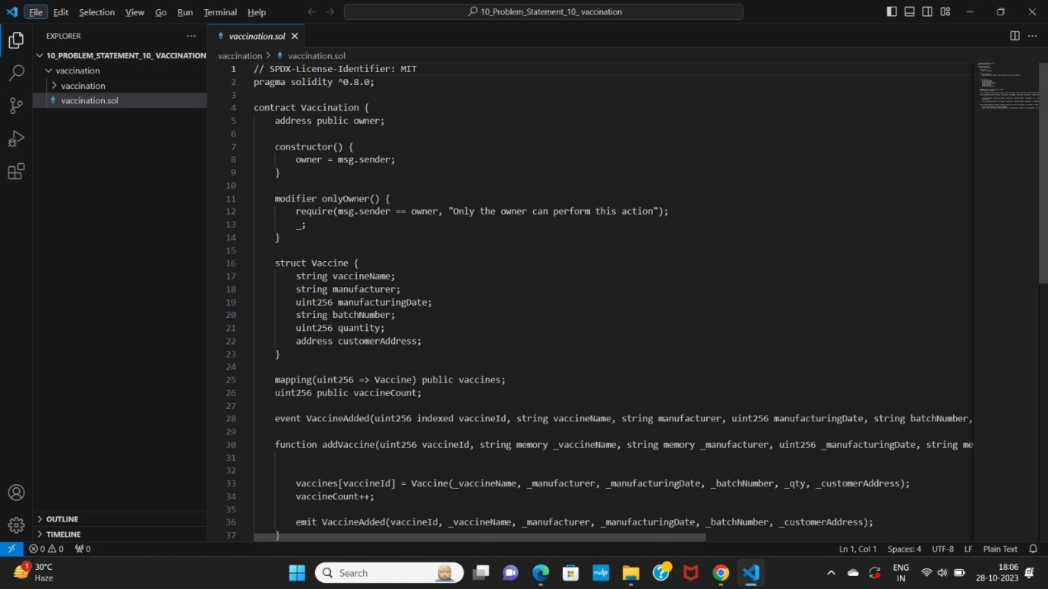

STEP 2:

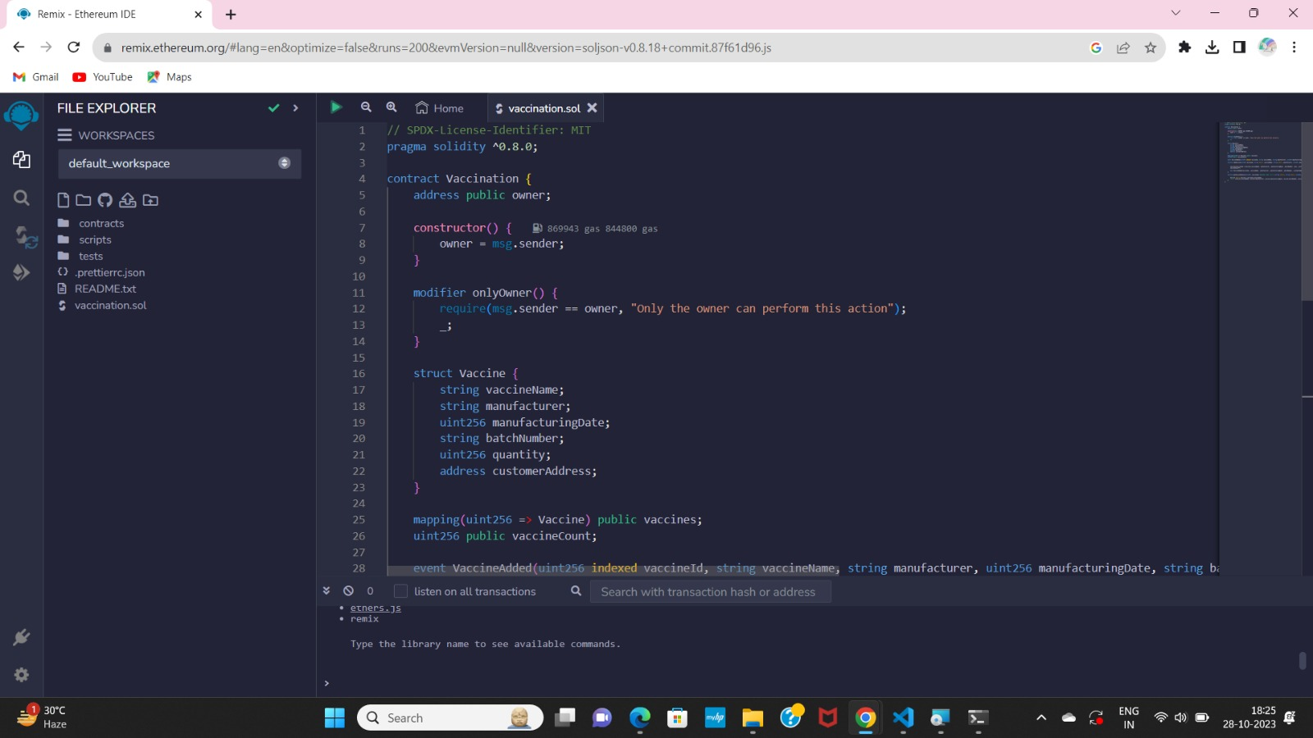

STEP 3:

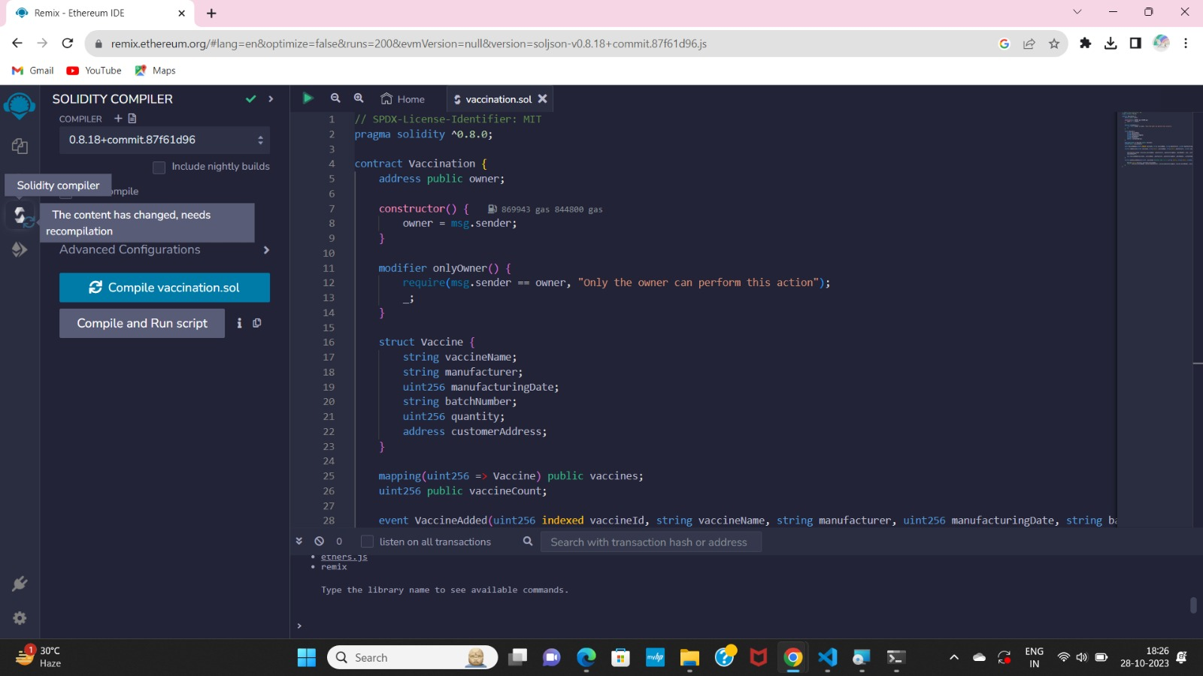

STEP 4:

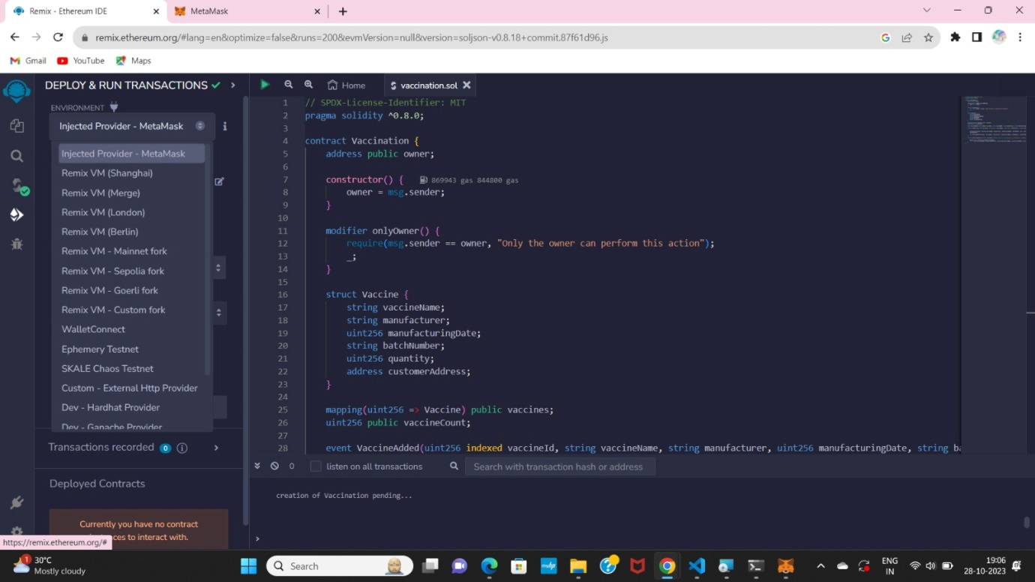

STEP 5:

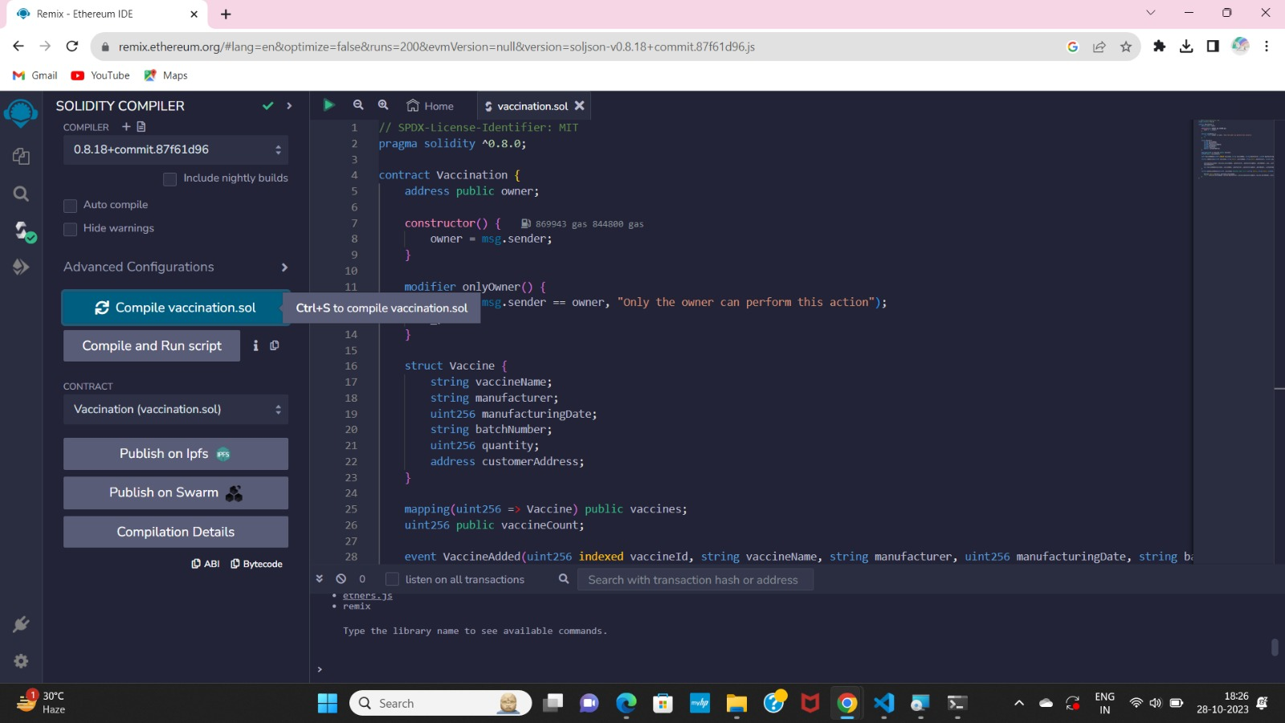

STEP 6:

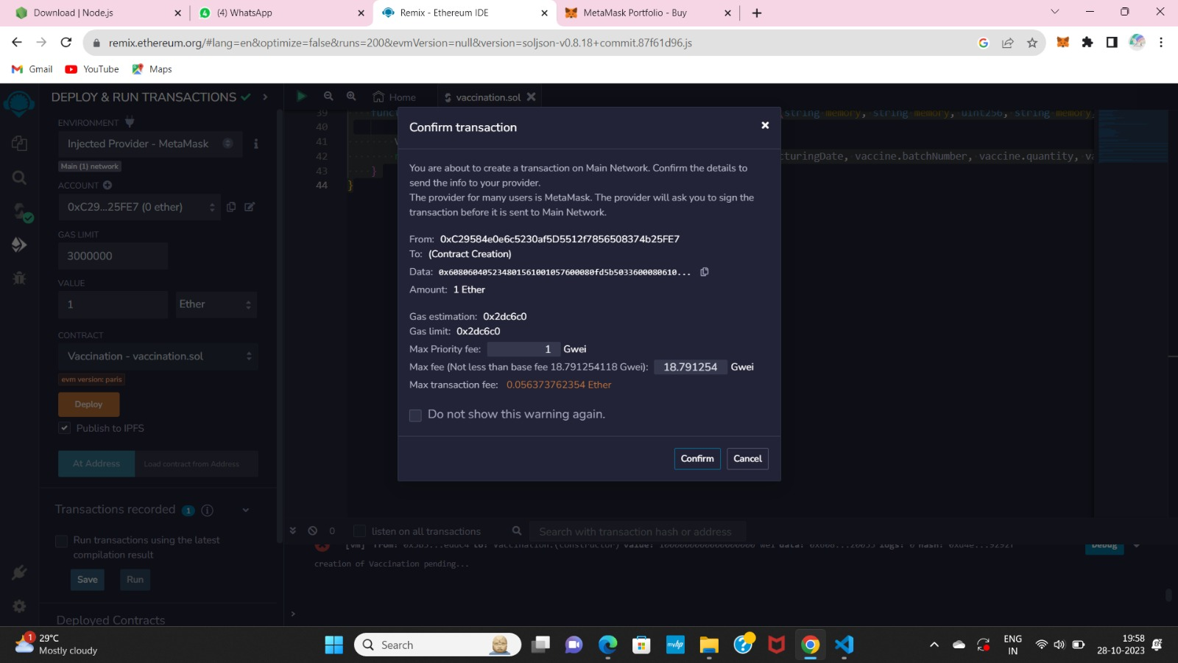

**10. ADVANTAGES :**

Utilizing blockchain technology for vaccine tracking offers numerous advantages. It ensures data security and transparency, with immutable records and real-time updates, reducing the risk of fraud and enabling stakeholders to verify information.

Blockchain minimizes counterfeit vaccines, automates processes, allows for traceability, and is globally compatible. It also ensures privacy and contributes to the effectiveness of public health initiatives.

In summary, blockchain enhances the security, transparency, and efficiency of vaccine tracking, bolstering the safety and effectiveness of vaccination programs.

**DISADVANTAGES :**

Blockchain-based vaccine tracking, while offering advantages, has its drawbacks. Implementation complexity, high costs, scalability issues, and energy consumption in some blockchain networks can hinder adoption.

Data privacy concerns and potential data loss due to lost access keys are also risks.

Establishing blockchain networks takes time, and regulatory challenges may complicate integration with existing healthcare systems.

Moreover, resistance to technological change from stakeholders is a potential obstacle. In conclusion, the benefits of blockchain in vaccine tracking must be balanced against these disadvantages, emphasizing the importance of careful planning and consideration before adoption.

**11.CONCLUSION :**

In conclusion, blockchain technology offers a promising solution for vaccine tracking, with its advantages of enhanced security, transparency, and efficiency. It can help combat counterfeit vaccines, automate processes, and improve traceability, all of which are critical for public health. However, the implementation of blockchain also comes with challenges, including complexity, cost, scalability, and regulatory issues. To fully realize the benefits, stakeholders must carefully weigh the advantages against these disadvantages and be prepared to invest in the necessary expertise and infrastructure. Blockchain has the potential to revolutionize vaccine tracking, but its successful integration requires a thoughtful and strategic approach.

**12.FUTURE SCOPE :**

The future of vaccine tracking through blockchain technology holds immense promise for the healthcare industry. Blockchain has already proven its worth by enhancing transparency, security, and efficiency in vaccine distribution and administration. Its future scope encompasses a range of crucial developments:

1. **Global** **Adoption**: More countries and organizations are likely to adopt blockchain-based vaccine tracking, establishing a universal standard for secure and transparent vaccine management.
2. **Transparency**: Blockchain will continue to provide real-time transparency in vaccine supply chains, fostering trust among stakeholders and the public.
3. **Supply chain optimization**: It will be instrumental in optimizing vaccine supply chains, reducing wastage, and ensuring vaccines reach even the most remote areas efficiently.
4. **Vaccine passport integration**: Blockchain will integrate with vaccine passports, offering a secure and private way for individuals to prove their vaccination status for travel and service access.
5. **Improved records**: Blockchain will help individuals maintain and access their immunization records, aiding in reminders and booster shots.
6. **Interoperabiliry**: Efforts to make vaccine tracking blockchains interoperable with other healthcare systems will create a comprehensive health data ecosystem.
7. **Fraud prevention**: The technology's immutability will deter counterfeit vaccines and ensure the administration of genuine vaccines.
8. **AI and IOT integration**:The integration of AI and IoT with blockchain will enhance tracking capabilities and real-time monitoring of vaccine storage conditions.

In summary, the future of vaccine tracking through blockchain promises to transform healthcare and vaccination management, but it also necessitates careful consideration of privacy, security, and standardization as it advances.

**13.APPENDIX :**

**SOURCE CODE :**

// SPDX-License-Identifier: MIT

pragma solidity ^0.8.0;

contract Vaccination {

address public owner;

constructor() {

owner = msg.sender;

}

modifier onlyOwner() {

require(msg.sender == owner, "Only the owner can perform this action");

_;

}

struct Vaccine {

string vaccineName;

string manufacturer;

uint256 manufacturingDate;

string batchNumber;

uint256 quantity;

address customerAddress;

}

mapping(uint256 => Vaccine) public vaccines;

uint256 public vaccineCount;

event VaccineAdded(uint256 indexed vaccineId, string vaccineName, string manufacturer, uint256 manufacturingDate, string batchNumber, address customerAddress);

function addVaccine(uint256 vaccineId, string memory _vaccineName, string memory _manufacturer, uint256 _manufacturingDate, string memory _batchNumber,uint256 _qty, address _customerAddress) external onlyOwner {

vaccines[vaccineId] = Vaccine(_vaccineName, _manufacturer, _manufacturingDate, _batchNumber, _qty, _customerAddress);

vaccineCount++;

emit VaccineAdded(vaccineId, _vaccineName, _manufacturer, _manufacturingDate, _batchNumber, _customerAddress);

}

function getVaccineDetails(uint256 _vaccineId) external view returns (string memory, string memory, uint256, string memory,uint256, address) {

Vaccine memory vaccine = vaccines[_vaccineId];

return (vaccine.vaccineName, vaccine.manufacturer, vaccine.manufacturingDate, vaccine.batchNumber, vaccine.quantity, vaccine.customerAddress);

}

}

**GITHUB & PROJECT DEMO LINK :**

GITHUB LINK: <https://github.com/sowndarya2002-github>

PROJECT DEMO LINK: <https://drive.google.com/file/d/1YVdmmKiv9_WuE_OuQ4h4enSZOv0crJrA/view?usp=drivesdk>